A

Micro-Project Report On

# “Webpage For Online Grocery Ordering System”



Submitted in partial fulfilment of the requirements

For the award of the course of Diploma of Engineering in

Information Technology

By

|  |  |  |  |
| --- | --- | --- | --- |
| **Sr.**  **No.** | **Name of student** | **Roll No.** | **Enrollment No.** |
| 1. | Dongare Payal Dayanand | 23IF321 | 2110510027 |
| 2. | Bhor Payal Ravindra | 23IF322 | 2110510029 |
| 3. | Daine Nisha Dipak | 23IF323 | 2110510030 |

**Under the Guidance of**

**Mr. Bodhe Y.U.**

**GOVERNMENT POLYTECHNIC, AWASARI (KH)**

# DEPARTMENT OF INFORMATION TECHNOLOGY



**SEMESTER – 5th (2021-22)**

**CERTIFICATE**

This is to certify the following students of semester 5th of Diploma in Information Technology of institute : Government Polytechnic Awasari(Kh)(code:1051) has completed the micro-project satisfactorily in the subject **- Client Side Scripting Language(22519)** for the academic year 2023-24 as per prescribed in the curriculum.

|  |  |  |  |
| --- | --- | --- | --- |
| **Sr.**  **No.** | **Name of student** | **Roll No.** | **Enrollment No.** |
| 1. | Dongare Payal Dayanand | 23IF321 | 2110510028 |
| 2. | Bhor Payal Ravindra | 23IF322 | 2110510029 |
| 3. | Daine Nisha Dipak | 23IF323 | 2110510030 |

**…………… …………….. ……………..**

|  |  |
| --- | --- |
| **Mr. Y. U. Bodhe** | **Mr.O.R.Varma Dr.Y.V.Chavan** |
| **Guide** | **HOD Principal** |
|  |  |

**Place :** Awasari (Kh)

**Date :** / /2023

# ACKNOWLEDGEMENT

With the successful completion of our micro-project, it becomes part of our duty to express gratitude to all those who made this work possible. We are thankful to the Maharashtra State Board of Technical Education for giving us such type of creative curriculum of diploma in Information Technology Engineering.

Also thanks to the institution for giving an opportunity to associate with an esteemed personality like Dr.Y.V.Chavhan. who has been a great source of inspiration and guidance and also for providing us infrastructural facilities to work in, without which this work would not have been possible.

We are whole heartedly thankful to Mr.O.R.Varma, Head of Information Technology Department for giving us freedom, inspiration, and encouragement to carry out this project.

We express our sincere gratitude to Mr. Y.U.Bodhe our Professor and Project Guide, Information Technology Department for his simulating guidance, continuous encouragement, and supervision throughout the present work.

|  |  |  |  |
| --- | --- | --- | --- |
| **Sr.**  **No.** | **Name of student** | **Roll No.** | **Enrollment No.** |
| 1. | Dongare Payal Dayanand | 23IF3021 | 2110510028 |
| 2. | Bhor Payal Ravindra | 23IF322 | 2110510029 |
| 3. | Daine Nisha Dipak | 23IF323 | 2110510030 |

**Annexure – I**

**PART A – Micro-Project Proposal**

# Webpage For Online Grocery Ordering System Using Javascript

**1.0 Brief Introduction :**

**JavaScript** is a versatile programming language commonly used for web development. In our Book Ordering System, JavaScript is used to add interactivity and functionality to web pages. It enables dynamic features like updating book information, handling user interactions, and managing the shopping cart.

**Event Handling** is a key concept in JavaScript. It involves responding to user actions, such as clicks or form submissions. In our system, event handling ensures that when a user clicks a book to add it to the cart, the system captures that action and updates the cart accordingly, providing a seamless and userfriendly experience.

**2.0 Aim of the Micro-Project :**

# To develop Webpage For Online Grocery Ordering System Using Javascript

**3.0 Intended Course Outcomes :**

1. Create interactive webpages using program flow control structure
2. Implement Array & Functions in JavaScript
3. Create event based web forms using JavaScript
4. Create interactive webpage using regular expression for validations

**4.0 Literature Review :**

A literature review of Online Grocery ordering systems implemented in JavaScript reveals their significance in enhancing the online shopping experience. These systems facilitate efficient product selection, offer user-friendly interfaces, and streamline payment processes. They also emphasize security to protect user data and transactions. The literature emphasizes the importance of responsive design for mobile users and highlights the role of JavaScript in creating dynamic and interactive features. Overall, the reviewed literature underscores the growing importance of JavaScript-based online Grocery ordering systems in modern e-commerce.

**4.0 Proposed Methodology :**

1. Discussion about given topic.
2. Selection of good leader and distribution of responsibilities.
3. Collection of information using different resources.
4. Analysis of given information.
5. Representation information in required formats.
6. Preparation of project report.
7. Completion and submission of assigned task.

**5.0 Resources Required** :

|  |  |  |  |  |  |
| --- | --- | --- | --- | --- | --- |
| **Sr.no.** | **Name of resource** | **Specification** | **Quantity** | **Remarks** | |
| 1 | PC | Intel(R) core2DUO CPU  67500@2.93 GH2 RAM  2.00  64-bit Windows OS | 01 |  | |
| 2 | Internet | Www.geeksforgeeks.org  Www.tutorialspoint.com | 01 |  | |
| 3 | Books | JavaScript : The Good Parts. | 01 |  |  |

**6.0 Action Plan** :

|  |  |  |  |  |
| --- | --- | --- | --- | --- |
| **Sr.no** | **Details of**  **activity** | **Planned started date** | **Planned finished date** | **Numbers of members** |
| 1 | Collection of information |  |  | All |
| 2 | Analysis of information |  |  |
| 3 | Representation of information |  |  |
| 4 | Preparation of report |  |  |
| 5 | Completion of assigned task |  |  |

**Annexure – II PART B – Micro-Project Report**

# Webpage For Online Grocery Ordering System Using Javascript

**1.0 Rationale :**

The Online Grocery Ordering System in JavaScript (JS) is a user-friendly web application designed to simplify the process of buying products online. This system leverages the power of JS to create an interactive and responsive platform for users. It allows users to browse a collection of products, view product details, and add them to their shopping cart. Event handling in JS ensures smooth interactions, such as adding products to the cart and processing orders. The system also provides a secure and efficient way to complete purchases, enhancing the overall products buying experience for customers. Through the application of JS and event handling, the Online Grocery Ordering System delivers a convenient and enjoyable online product shopping solution.

**2.0 Course Outcomes Addressed :**

1. Create interactive webpages using program flow control structure
2. Implement Array & Functions in JavaScript
3. Create event based web forms using JavaScript
4. Create interactive webpage using regular expression for validations

**3.0 Literature Review :**

A literature review of Online Grocery ordering systems implemented in JavaScript reveals their significance in enhancing the online shopping experience. These systems facilitate efficient product selection, offer user-friendly interfaces, and streamline payment processes. They also emphasize security to protect user data and transactions. The literature emphasizes the importance of responsive design for mobile users and highlights the role of JavaScript in creating dynamic and interactive features. Overall, the reviewed literature underscores the growing importance of JavaScript-based online Grocery ordering systems in modern e-commerce.

**4.0 Actual Methodology Followed :**

1. Discussion about given topic.
2. Selection of good leader and distribution of responsibilities.
3. Collection of information using different resources.
4. Analysis of given information.
5. Representation information in required formats.
6. Preparation of project report.
7. Completion and submission of assigned task.

**5.0 Actual Resources Used :**

|  |  |  |  |  |  |
| --- | --- | --- | --- | --- | --- |
| **Sr.no.** | **Name of resource** | **Specification** | **Quantity** | **Remarks** | |
| 1 | PC | Intel(R) core2DUO CPU  67500@2.93 GH2 RAM  2.00  64-bit Windows OS | 01 |  | |
| 2 | Internet | Www.geeksforgeeks.org  Www.tutorialspoint.com | 01 |  | |
| 3 | Books | JavaScript : The Good Parts. | 01 |  |  |

**6.0 Outputs of the Micro-Project :**

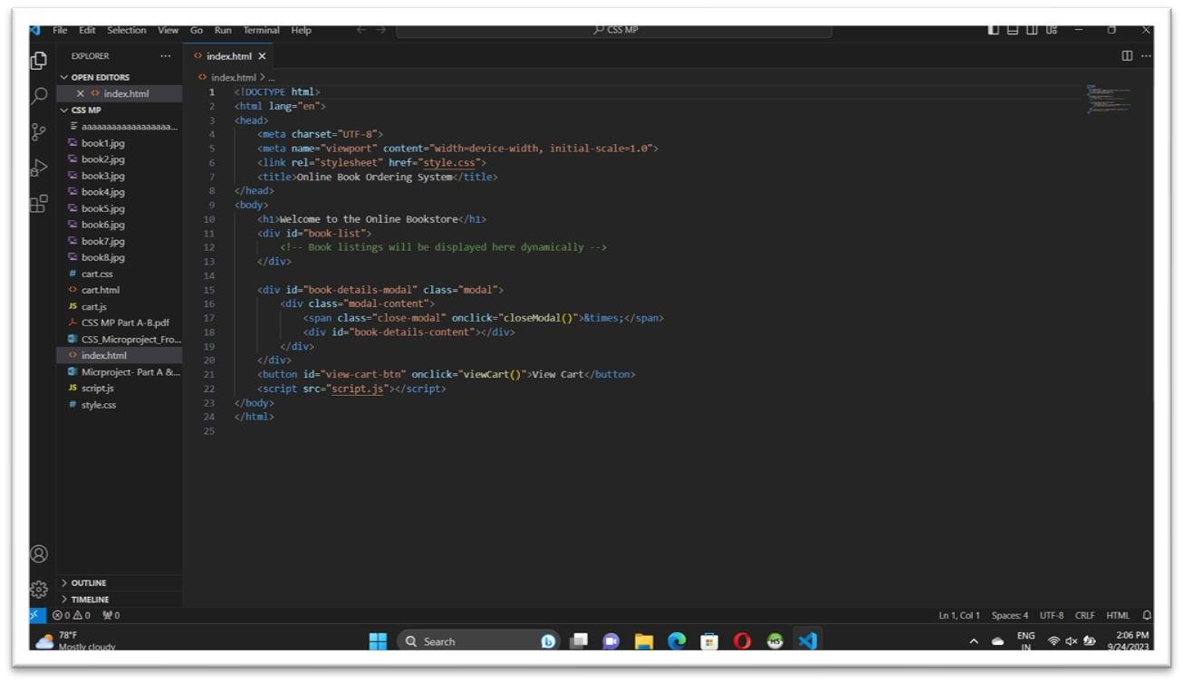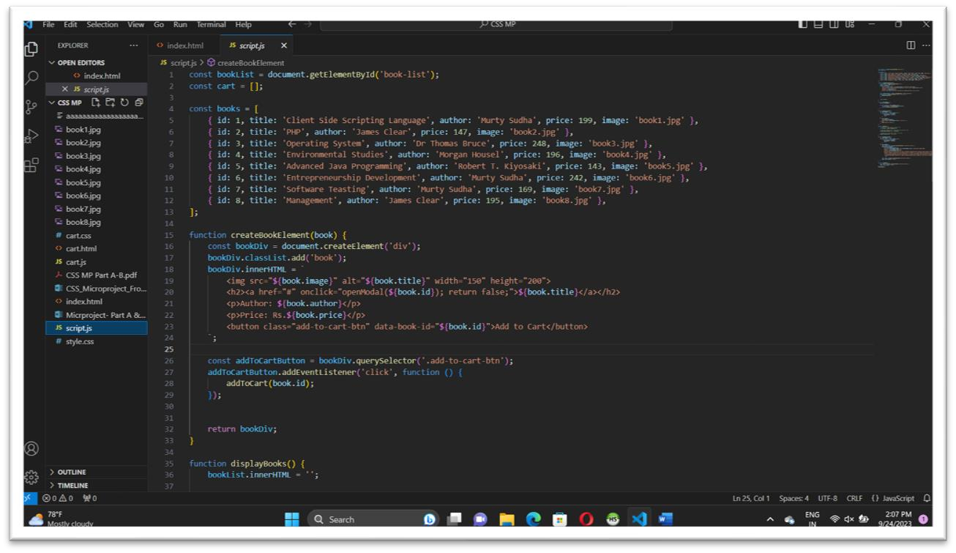

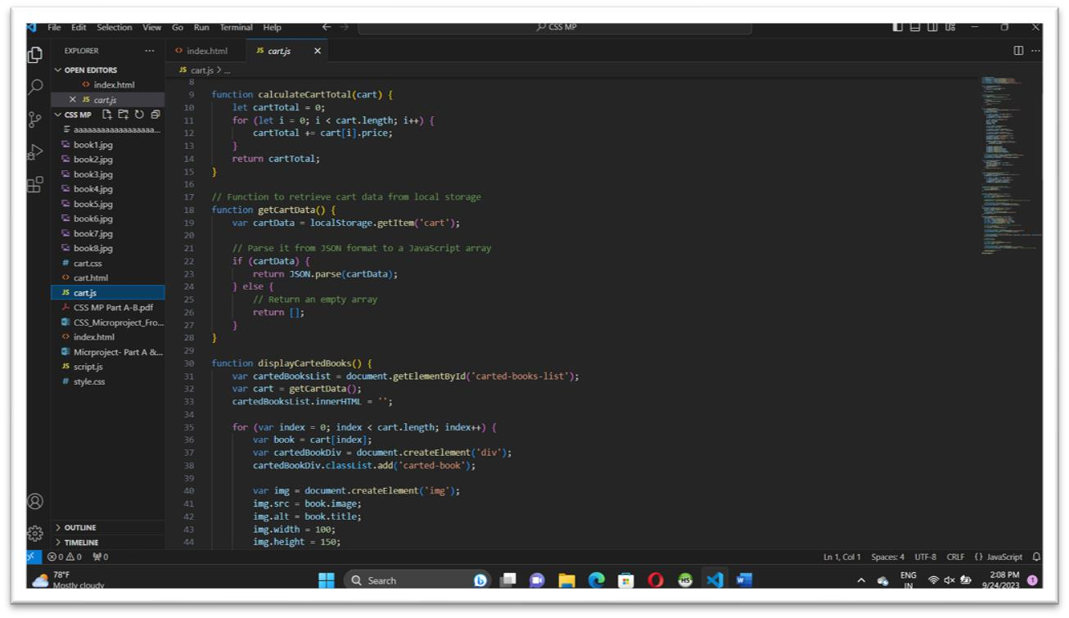

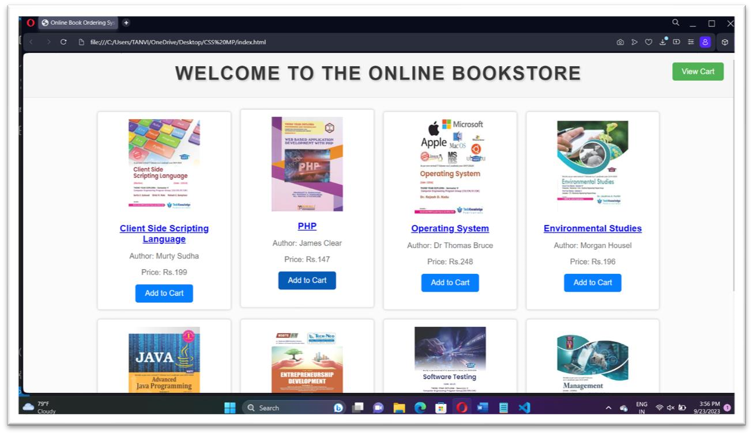

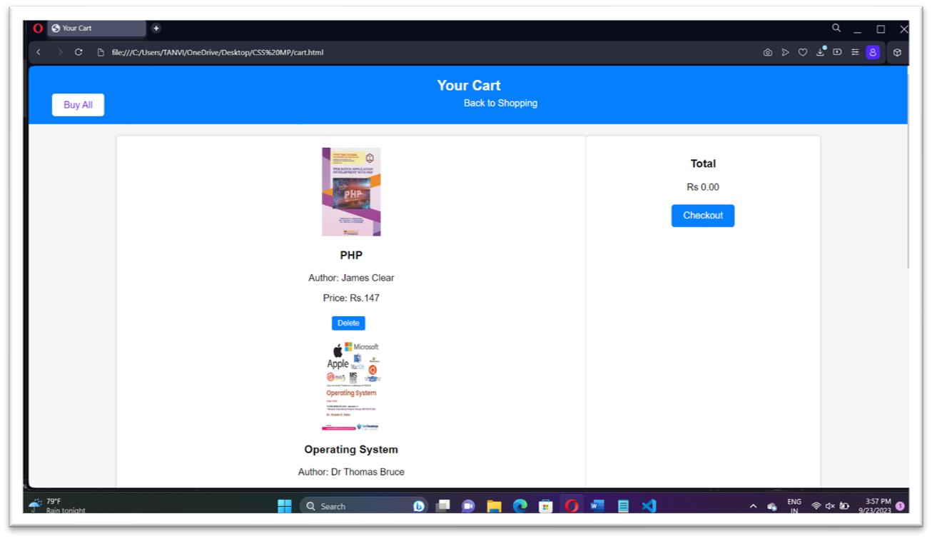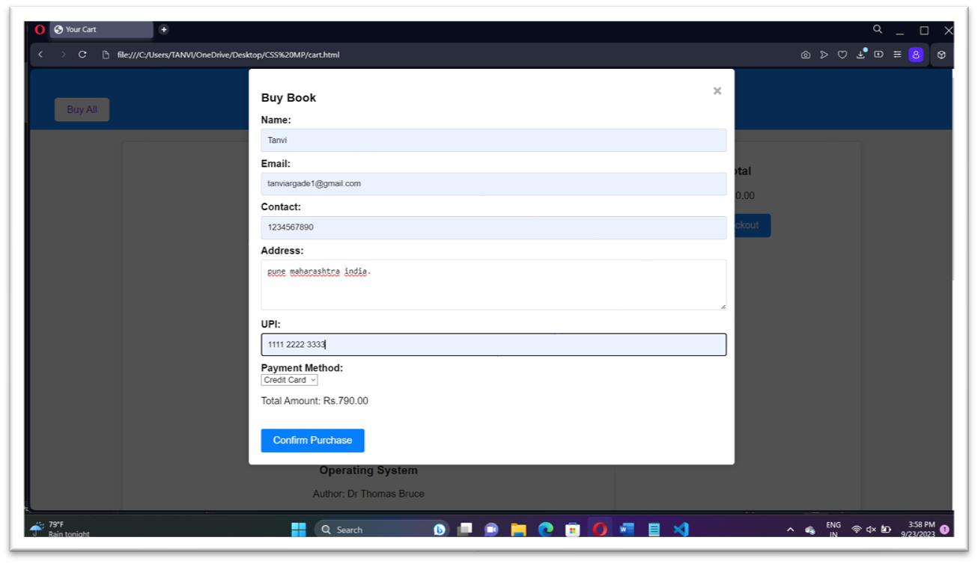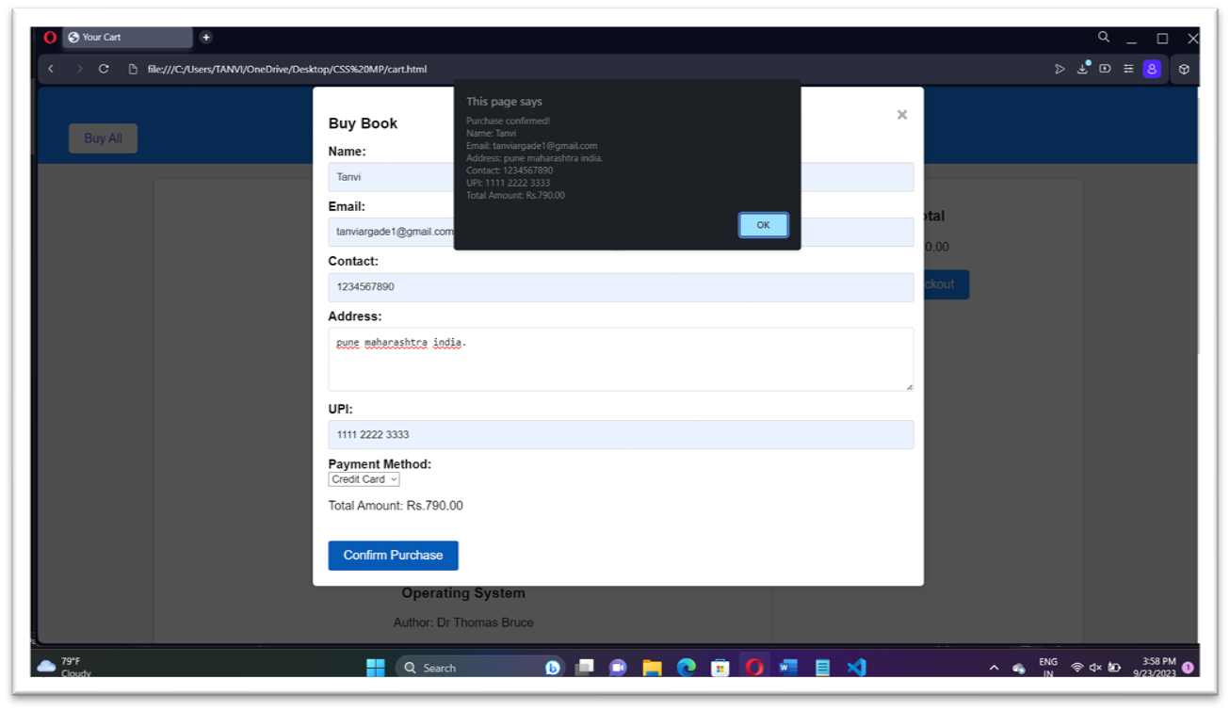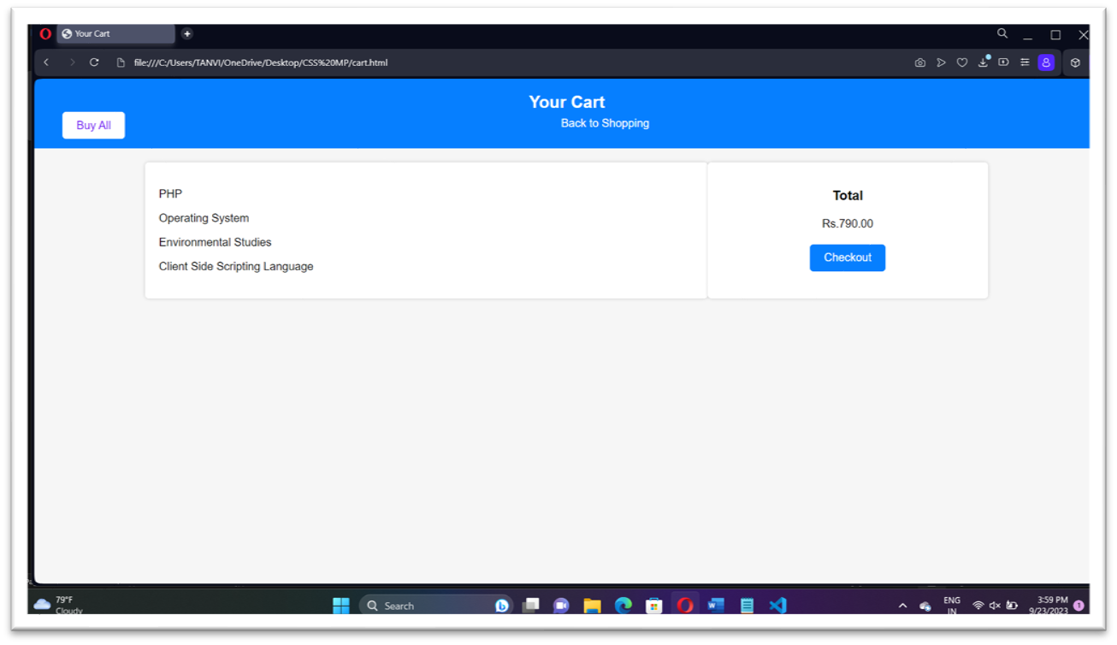

**7.0** **Skill Developed / learning out of this Micro-Project :**

* 1. Analytical and logical skills
  2. Interpretation of data
  3. Demonstrated working as a leader/a team member
  4. Followed safety practices
  5. Followed ethical practices
  6. Maintained tools & equipment

**8.0 Applications of this Micro-Project :**

JavaScript is commonly used for creating web pages. It allows adding dynamic behaviour to the webpage and adding special effects to the webpage.

**9.0 Area of Future Improvement :**

We have developed webpage with basic JavaScript functionalities. In future we would like to add various additional features to our webpage.